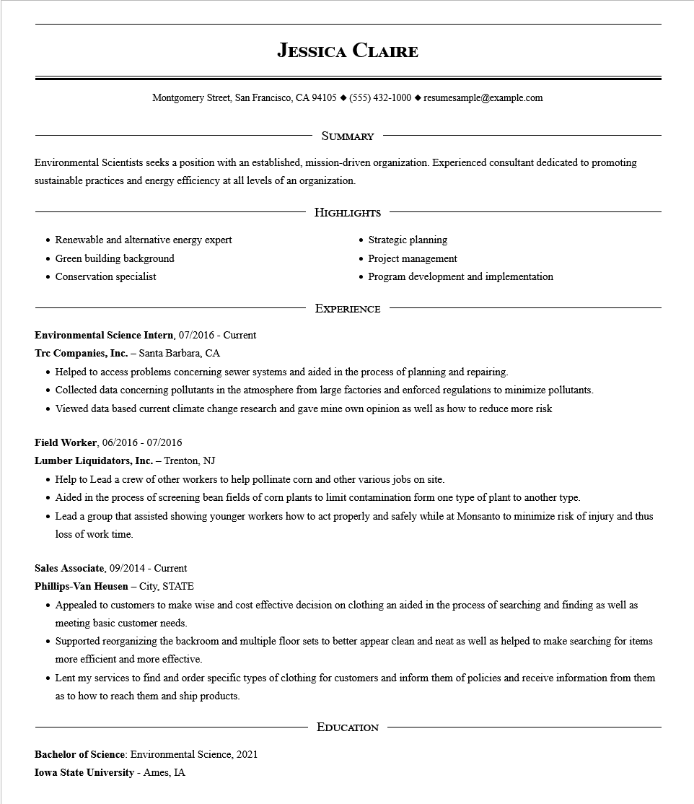
JESSICA CLAIRE
Montgomery Street, San Francisco, CA 94105 ♦ (555) 432-1000 resumesample@example.com
SUMMARY
Environmental Scientists seeks a position with an established, mission-driven organization. Experienced consultant dedicated to promoting sustainable practices and energy efficiency at all levels of an organization.
Renewable and alternative energy expert
• Green building background
• Conservation specialist
HIGHLIGHTS
• Strategic planning
• Project management
• Program development and implementation
EXPERIENCE
Environmental Science Intern, 07/2016 - Current
Trc Companies, Inc. - Santa Barbara, CA
• Helped to access problems concerning sewer systems and aided in the process of planning and repairing.
Collected data concerning pollutants in the atmosphere from large factories and enforced regulations to minimize pollutants.
• Viewed data based current climate change research and gave mine own opinion as well as how to reduce more risk
Field Worker, 06/2016 - 07/2016
Lumber Liquidators, Inc. - Trenton, NJ
• Help to Lead a crew of other workers to help pollinate corn and other various jobs on site.
• Aided in the process of screening bean fields of corn plants to limit contamination form one type of plant to another type.
• Lead a group that assisted showing younger workers how to act properly and safely while at Monsanto to minimize risk of injury and thus loss of work time.
Sales Associate, 09/2014 - Current
Phillips-Van Heusen - City, STATE
• Appealed to customers to make wise and cost effective decision on clothing an aided in the process of searching and finding as well as meeting basic customer needs.
• Supported reorganizing the backroom and multiple floor sets to better appear clean and neat as well as helped to make searching for items more efficient and more effective.
• Lent my services to find and order specific types of clothing for customers and inform them of policies and receive information from them as to how to reach them and ship products.
Bachelor of Science: Environmental Science, 2021 Iowa State University - Ames, IA
EDUCATION

